YOUR Board Mission  Board mission here  “Regulation is intended to offer some assurance to the public that the regulated individual is competent to provide certain services in a safe and effective manner.”  -Schmitt & Shimberg | Your Board Name Here  Board Address City, ST, Zip | Recipient Name  Address  City, ST ZIP Code | Your Duty to Report  - Take action to protect the public, your work environment, and the reputation of your profession.  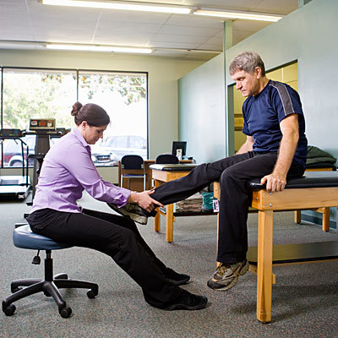

Professional and Legal Responsibility  Physical therapists and physical therapist assistants work with vulnerable people. Every licensee has a responsibility to act in a professional manner. Licensees also have a responsibility, a duty, to report practitioners that are incompetent, unprofessional, or unlawful. When health care practitioners act outside of normal professional standards, the public loses trust in that person or potentially the profession as a whole.  The state board’s first priority is protecting the public and may use a variety of remedial and punitive sanctions to prevent future incidents. When PTs, PTAs, or employers report incidents to the Board, the complaint is investigated, and, if substantiated, | “Physical therapists shall discourage misconduct by health care professionals and report illegal or unethical acts to the relevant authority, when appropriate.”  -APTA Code of Ethics  appropriate action is taken. The Board will work to correct the practitioner’s behavior and increase the understanding of the problem.  If an issue is never reported, the practitioner can simply be fired or resign and seek employment at another facility with no consequence, potentially putting others at risk.  When Should I Report?  It is your duty to report another practitioner when you have reasonable cause to believe that person is unable to practice safely, has engaged in unprofessional conduct, violated laws or rules, or committed unethical practices. Many jurisdictions have mandatory reporting rules; failure to report could result in professional disciplinary action by the state Board. | What You Need to Know  - Each state licensing authority has the ability and responsibility to discipline its licensees.  - State’s reporting requirements vary; it’s your responsibility to know the law.  - Each complaint is investigated to determine if there’s reason to move forward with a case.  What You Need to Do  - Look-up a licensed individual directly from the board's website.  - Submit a complaint to the Board with as much detail as possible.  - Provide your name and contact information to allow the Board to follow up with you.  - File your report accurately and completely, including all content the agency report requires.  Contact Us  Your Board Here  Board Address City, ST, Zip  Board Phone  Board email  Board website

